# Phase 4: Process Automation (Admin) – Salesforce Hospital Management Project

## 1. Validation Rule – Appointment date must be future-dated

**Goal:** Prevent users from saving an appointment with a past date.

**Steps:** 1. Go to **Setup → Object Manager → Appointment → Validation Rules**.

2. Click **New Rule**.

3. Rule Name: Future_Appointment_Date

4. Formula: Appointment_Time__c < NOW()

5. Error Message: “Appointment date and time must be in the future.”

6. Choose the error location (e.g., Appointment Date field).

7. Save & Activate.

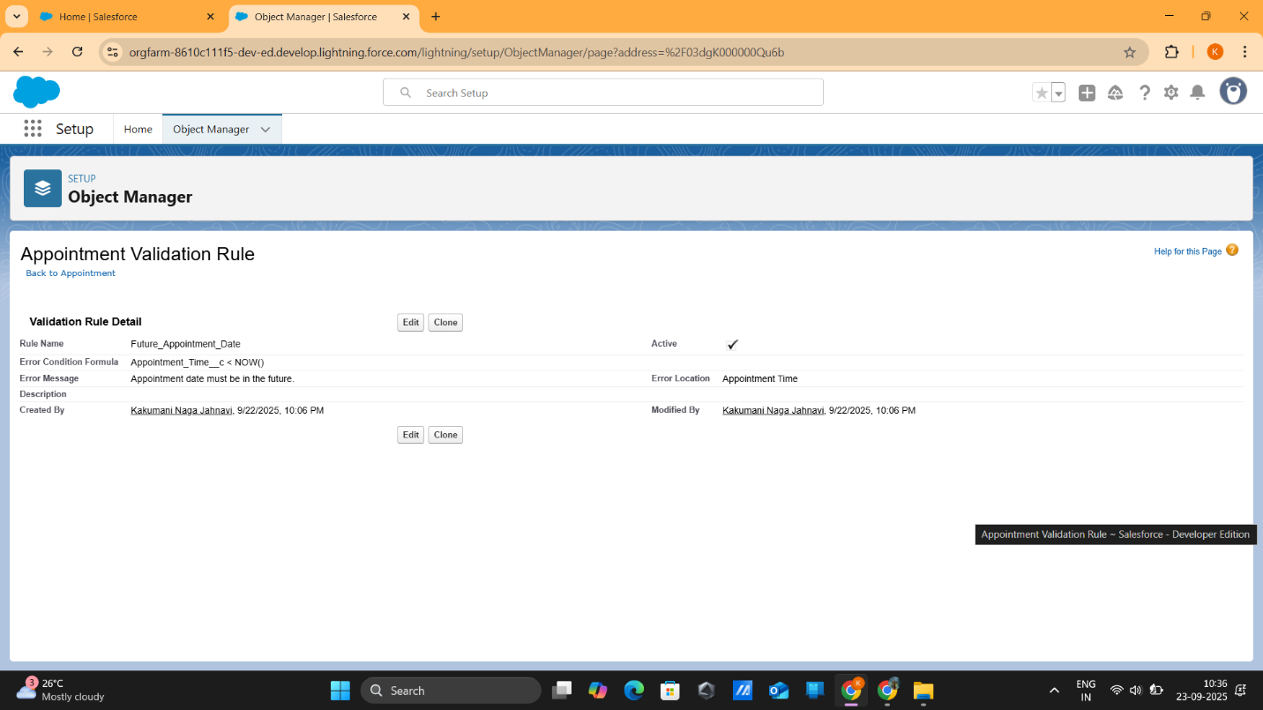

## 2. Workflow – Auto ‘Appointment Confirmation’ email to patients

**Goal:** Send an email when a new appointment is created.

**Steps:**

1. Go to **Setup → Workflow Rules → New Rule**.

2. Object: **Appointment**. 3. Evaluation Criteria: created.

4. Rule Criteria: TRUE (always run when a new record is created).

5. Add Workflow Action → **New Email Alert**: - Choose an **Email Template** (create beforehand with merge fields like Patient Name, Date, Doctor). - Recipient Type: Related Contact/Patient Email field.

6. Save, then **Activate**.

*Note: Salesforce recommends using* ***Record-Triggered Flow*** *for future-proofing instead of Workflow Rules.*

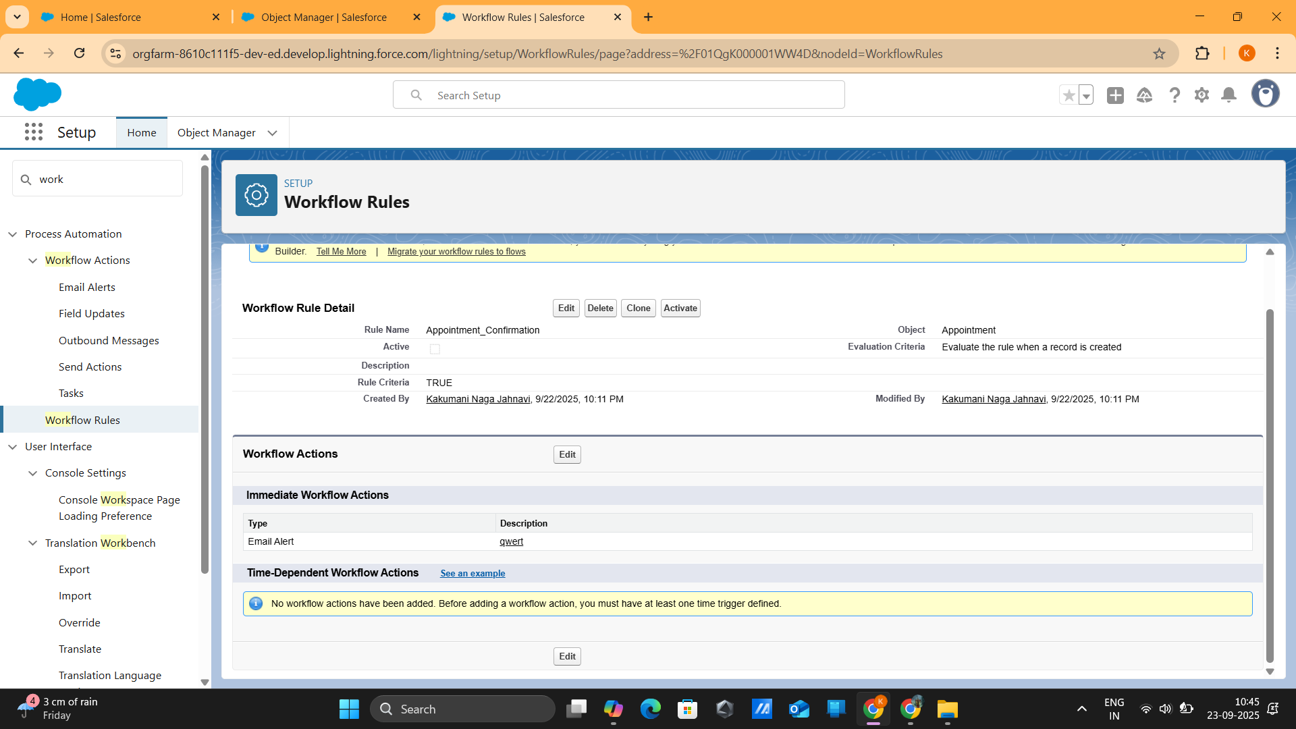

## 3. Approval Process – High-value insurance claims need admin approval

**Goal:** Claims above a certain amount must go to Admin.

**Steps:**

1. Go to **Setup → Approval Processes → Insurance Claim → Create New Approval Process**.

2. Use **Jump Start Wizard**.

3. Entry Criteria: Claim_Amount__c > 50000

4. Approver: Automatically assign to **Admin role/user**.

5. Initial Submission Actions: - Lock the record. - Send Email Alert to Admin.

6. Save & Activate.

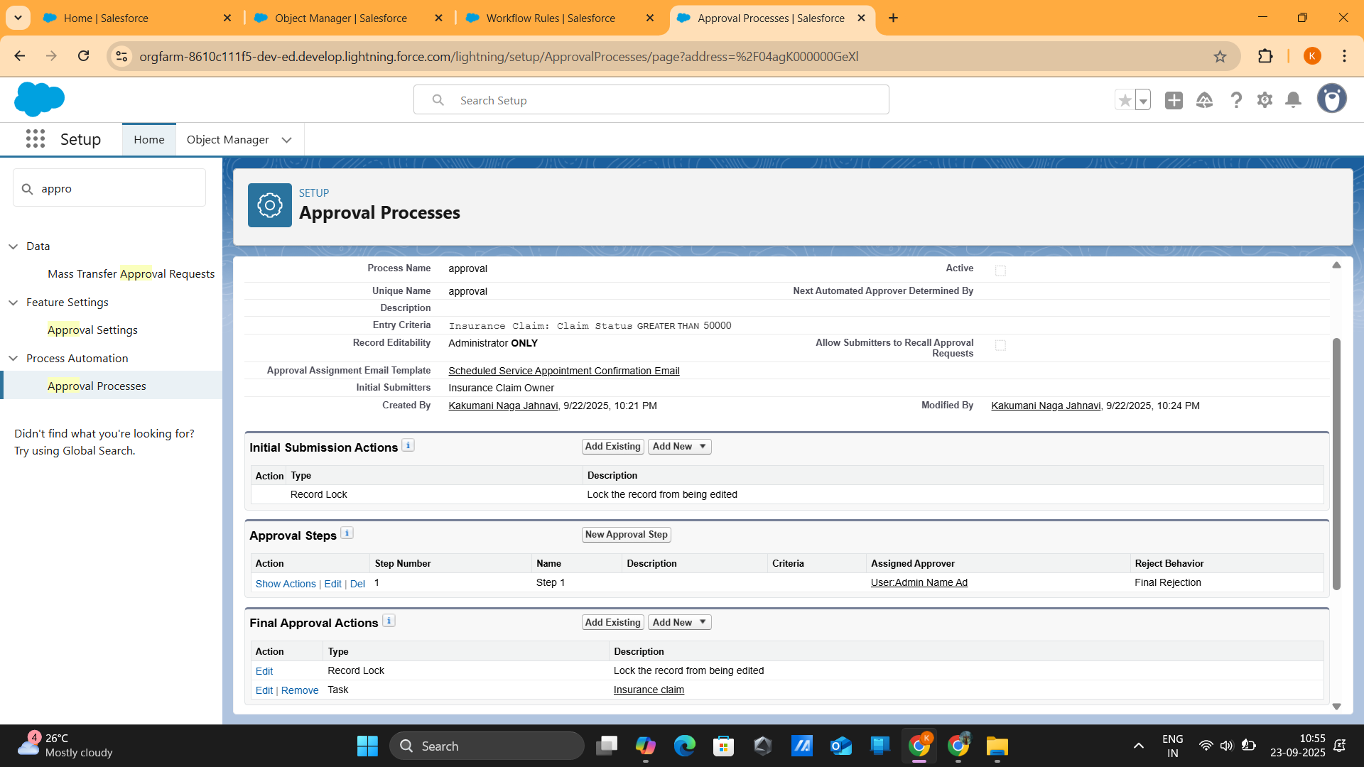

## 4. Flow Builder – Auto-assign doctors based on specialization

**Goal:** Assign the right doctor when an appointment is booked.

**Steps:**

1. Go to **Setup → Flows → New Flow → Record-Triggered Flow**.

2. Object: **Appointment**.

3. Trigger: On Create.

4. Add **Get Records** element: - Object: Doctor - Filter: Doctor.Specialization__c = {!$Record.Specialization__c} - How Many Records to Store: Only the first record

5. Add **Update Records** element: - Record: $Record - Field Mapping: Appointment.Doctor__c = {!Get_Doctor.Id}

6. Optional: Add **Decision element** to handle cases where no doctor is found.

7. Save & Activate.

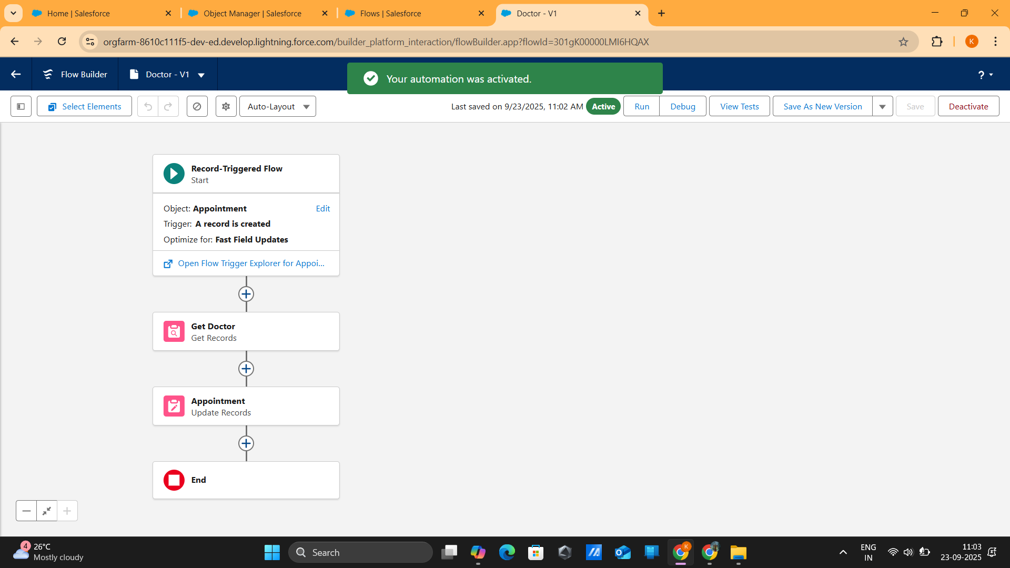

## 5. Custom Notification – Urgent/emergency appointments alert doctors

**Goal:** Notify doctors immediately in Salesforce (and mobile app).

**Steps:**

1. Go to **Setup → Notification Builder → Custom Notifications → New**: - Name: Urgent_Appointment_Alert - Type: In-app + Mobile

2. Create **Record-Triggered Flow**: - Object: Appointment - Trigger: When a record is created or updated - Entry Condition: Urgency__c = 'Emergency'

3. Add **Send Custom Notification Action**: - Notification Type: Urgent_Appointment_Alert - Recipient: $Record.Doctor__c - Message: Urgent appointment scheduled for patient {!$Record.Patient__r.Name} at {!$Record.Appointment_Date__c} - Title: 🚨 Emergency Appointment

4. Connect **Start → Send Custom Notification → End**. 5. Save & Activate.

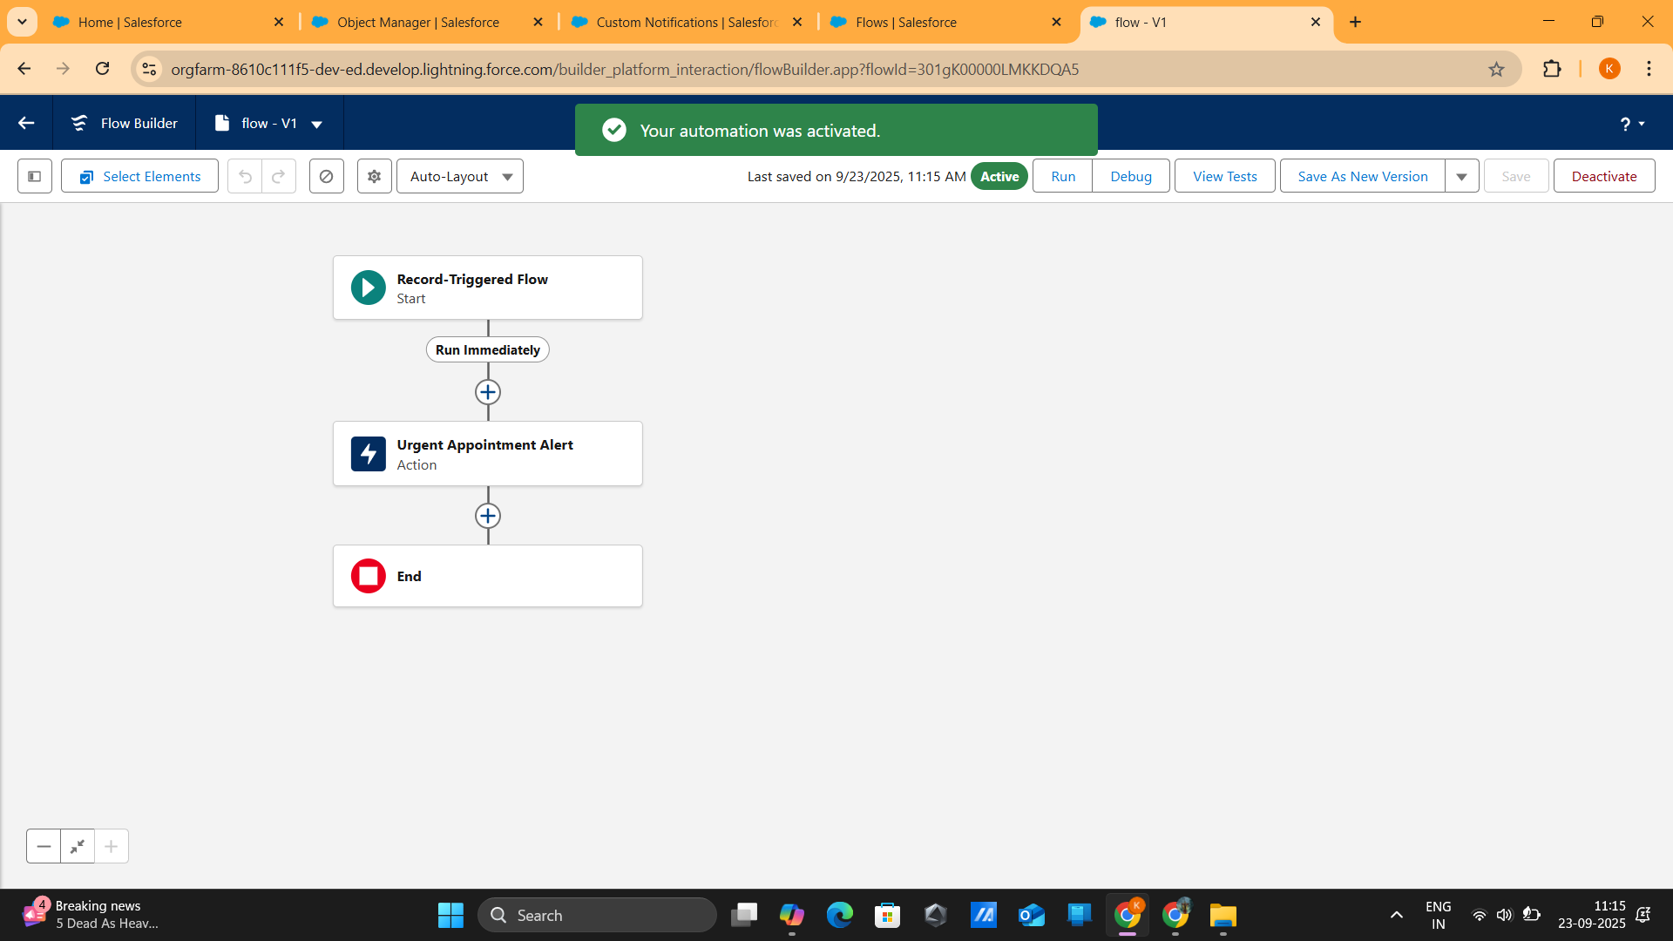

## Outcome of Phase 4

* **Validation:** Ensures appointment dates are in the future.
* **Automation:** Sends confirmation emails automatically.
* **Approval Control:** High-value insurance claims go to Admin.
* **Smart Assignment:** Doctors are auto-assigned based on specialization.
* **Immediate Alerts:** Doctors receive notifications for urgent appointments.